TRANSIT AND ECONOMIC OPPORTUNITY ANALYSIS IN CHICAGO
Jhanavi Sankar
12/4/25
INTRODUCTION
Urban mobility and transportation continue to shape access to employment, education, and essential services which are fundamental to economic opportunities. In Chicago, where many households lack private vehicles, public transportation has become a lifeline connecting its residents to jobs and essential services such as healthcare. Research indicates that transportation costs are particularly burdensome for low-income households who contribute a greater percentage of their income to transportation costs than higher-income households.
Chicago area’s transit network system is extensive; the Chicago Transit Authority (CTA) and PACE, serve more than 2 million each weekday at cost per rider that is found to be the lowest in the country. According to a survey conducted by Chicago Jobs Council, transportation is identified as a significant barrier to finding and keeping a job. Additionally, spatial inequity in transit access is deeply intertwined with patterns of historical segregation and land-use decisions that shape where people work and live. These structural factors affect not only physical access to transit stops but also travel time and job accessibility. Research on geographical impacts on economic mobility finds that longer commute times are significantly associated with reduced employment stability.
PROBLEM STATEMENT:
Despite the Chicago Transit Authority (CTA) operating more than 10,000 bus stops and 145 rail stations, transit access does not translate into equitable mobility across the city. Many neighborhoods with high transit dependence, particularly on the South and West Sides experience longer average commutes and more unreliable service than their North Side counterparts.
These disparities persist even though low-income residents are disproportionately reliant on public transportation. This spatial mismatch between where people live and where jobs are located reduces economic mobility and contributes to persistent inequality. The problem, therefore, is not just having transit access but also assessing how well it aligns with the population needs, particularly for communities facing structural barriers. Understanding these patterns spatially is essential for designing equitable transit improvements.

METHODOLOGY:
This project includes spatial analysis which was conducted in ArcGIS pro, with outputs published as static and interactive web layers for visualization.
The analysis draws from several datasets:
- Demographic and socioeconomic data – Block-group-level poverty rates and population characteristics from the U.S. Census Bureau’s 2022 American Community Survey (ACS).
- Transit infrastructure – Chicago Transit Authority (CTA) bus stops and rail stations from the City of Chicago Data Portal (2024).
- Commute-time distribution – ACS Table B08303 (“Travel Time to Work”) aggregated to block groups.
- Administrative boundaries – Chicago Community Areas and census block groups from the City of Chicago GIS Repository.
These layers were projected into NAD 1983 StatePlane Illinois East FIPS 1201 (US Feet) for local spatial accuracy during analysis. A Web Mercator version was later prepared for web publishing.

Cleaning and Integration of Census & Commute Data: Income and Poverty Level Ratio statistics were derived from ACS 5-Year Estimates. Column titles were cleaned and only rows containing poverty status below 50% and poverty status from 50-99% were retained along with, total poverty estimates. Below poverty percentages were then calculated from the above calculations and a field was created to create choropleths and cluster maps.

Commute-time frequencies from ACS Table B08303 were cleaned in Excel and converted to percentages for standardized comparison. The table was imported into ArcGIS Pro and joined to census block groups using the 12-digit GEOID. To ensure compatibility with downstream analysis, all fields were exported into a permanent geodatabase feature class. Derived variables included: 1) Percentage of workers commuting in each time bin (e.g., 10–14 minutes, 35–44 minutes). 2)A Dominant Commute Time field calculated using a python expression to identify the most common commute category in each block group.
- Poverty Rate Choropleth Mapping: Block-group poverty rates were symbolized using a five-class quantile choropleth map to reveal spatial concentrations of economic disadvantage. This layer serves as the baseline socioeconomic indicator for comparison with transit patterns.
- Kernel Density Estimation (KDE) of Transit Supply: To measure spatial accessibility to the transit network, a Kernel Density Estimation (KDE) surface was generated using CTA bus stops and rail stations. A search radius of 6000 was determined as the best choice to illustrate the spatial differences. KDE outputs categorize transit density from “Very Low” to “Very High,” enabling identification of areas underserved by frequent or nearby transit stops.
- Spatial Clustering of Poverty and Transit Density: A bivariate cluster analysis was conducted by combining 1) Below Poverty-rate percentages

2) KDE transit-density categories

A new four-class cluster scheme was generated to highlight areas of: High poverty / low transit access, Low poverty / high transit access, Moderate poverty / moderate transit access, High poverty / moderate transit access. This step identifies mismatches between population need and transit supply.
- Commute Burden Modeling: To understand mobility outcomes, commute-time distributions were analyzed at the block-group scale. The Dominant Commute field was calculated using python where each block group was assigned a commute category representing the largest share of workers. Categories ranged from “Under 10 minutes” to “60+ minutes.” The resulting map is the commute burden map which is a categorical symbology map that visualizes the dominant commute category across Chicago.
RESULTS:
Figure 1: Spatial Distribution of Poverty in Chicago
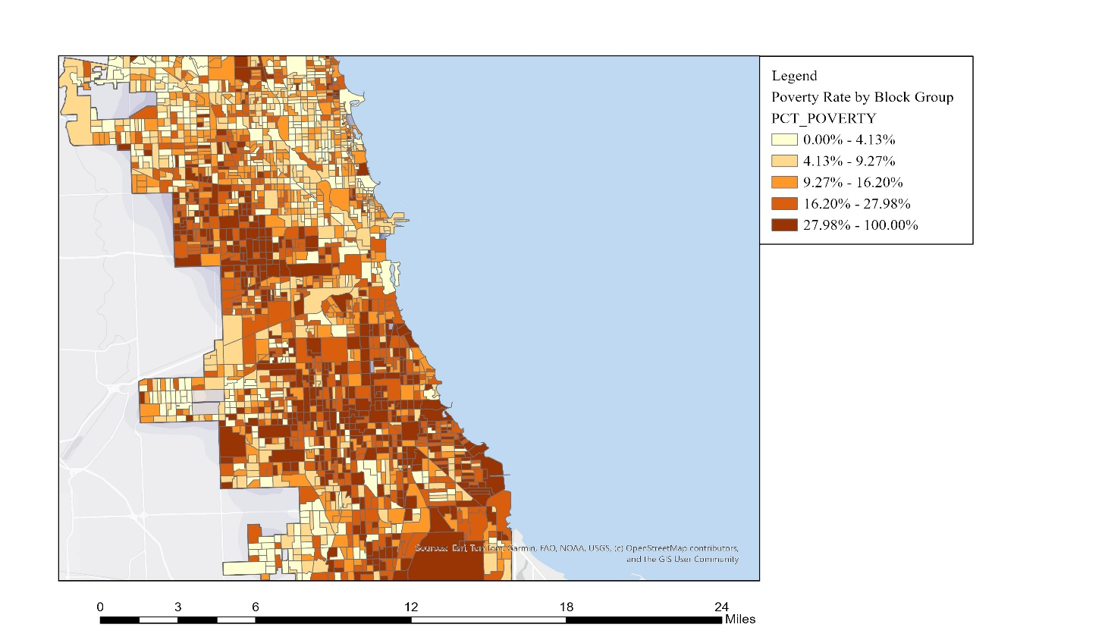
The poverty map reveals a clear and persistent geographic pattern in Chicago: poverty is heavily concentrated on the South and West Sides, with many block groups exhibiting poverty rates above 28% which exceed the citywide average. Large areas such as Englewood, North, Lawndale, South Chicago, West Lawn, West Garfield Park, and Roseland show some of the highest poverty intensities, reflecting long-standing patterns of racial segregation and economic disinvestment.
In contrast, neighborhoods on the North Side, including Lincoln Park, Lakeview, and North Center, display some of the lowest poverty levels, often below 10%. The spatial contrast is stark, forming a north–south economic divide across the city. This uneven distribution of socioeconomic disadvantage provides essential context for evaluating transit access and commute outcomes.
Figure 2: Kernel Density of Transit Access in Chicago
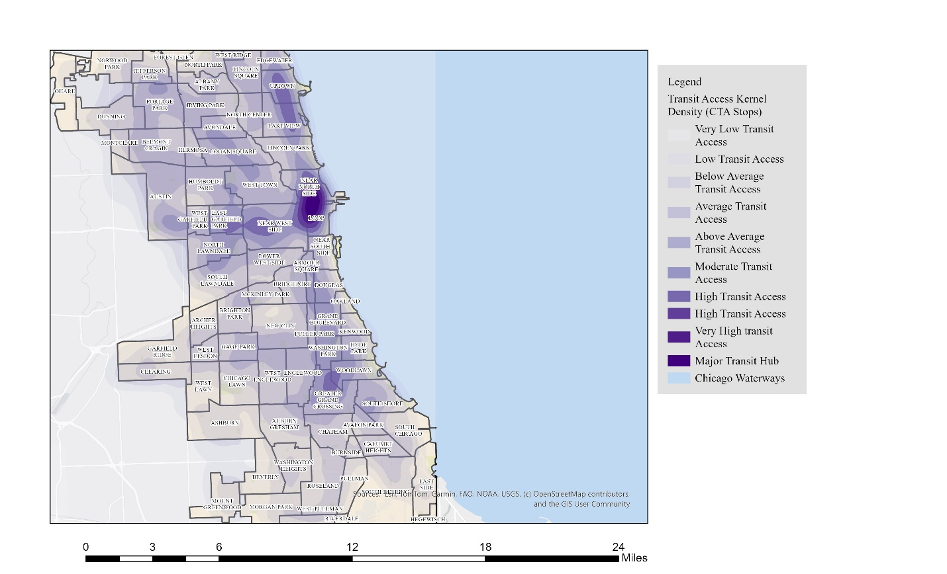

The kernel density surface highlights significant variation in transit access across Chicago, with the greatest concentration of CTA bus stops and rail stations located in and around the Loop, Near North Side, and Near West Side. These areas form the city’s primary mobility core, receiving “Very High Transit Access” classifications that reflect dense service and short walking distances to transit. Transit access gradually declines moving outward from the downtown area, with many neighborhoods on the Far South Side, Southwest Side, and portions of the Northwest Side exhibiting “Low” or “Very Low Transit Access.”
These lower-density transit zones often coincide with areas that are less walkable, farther from job centers, or historically underserved by frequent bus or rail service. The KDE map suggests a spatial imbalance in transit supply: while the North Side and central areas benefit from dense, overlapping transit networks, communities farther from the urban core particularly those with higher concentrations of low-income households face reduced accessibility to reliable, high-frequency transit. This pattern sets the foundation for understanding why some neighborhoods experience disproportionately longer commute times despite geographic proximity to transit infrastructure.
Figure 3: Distribution of Poverty and Transit Density Across Identified Spatial Clusters
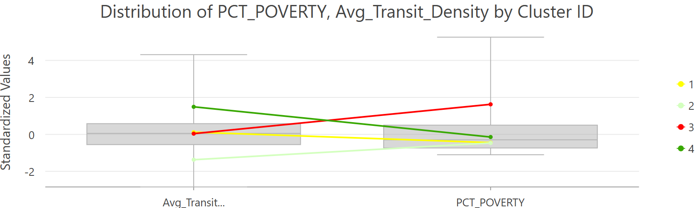
This chart summarizes how poverty rates and transit-access density vary across the four spatial clusters generated in the analysis. High-poverty clusters shown by the red line and moderate poverty depicted by the green line show consistently lower transit density, while low-poverty clusters such as the green line align with above-average transit access. The crossing pattern of the lines illustrates a possible inverse relationship between socioeconomic disadvantages and transit supply.
Average Transit Density is a standardized measure derived from your Kernel Density Estimation (KDE) surface.
It reflects:
- How many CTA transit stops (bus + rail) are located within and around a block group,
- Weighted by proximity (closer stops contribute more density) In the chart, this is shown as a z-score (standardized value) so clusters can be compared directly.
Poverty Percentage (PCT_POVERTY) refers to:
- The share of residents in each census block group living below the Federal Poverty Level,
- Averaged across all block groups within each cluster. This variable was also standardized (converted to z-scores) to allow comparison with transit density on the same scale.

Figure 4: Mean Poverty Rate and Transit Density by Cluster
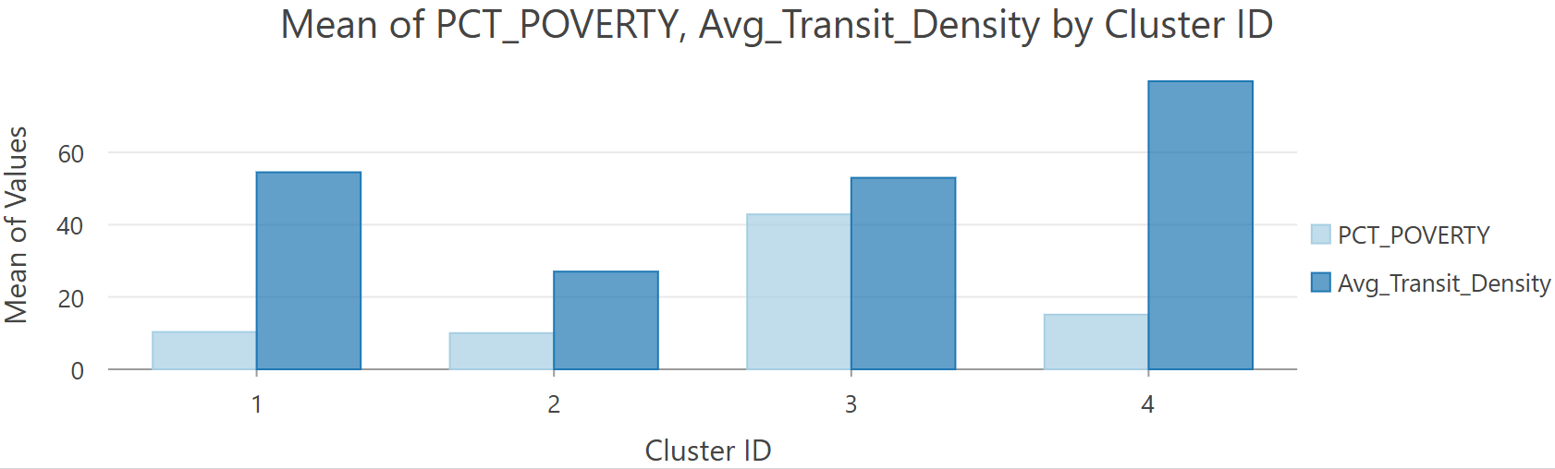
This chart compares the average poverty rate and average transit density across the four spatial clusters identified in the analysis. Cluster 3 exhibits the highest average poverty rate, yet only moderate transit density, highlighting a mismatch between socioeconomic need and transit availability. Cluster 4 shows the strongest transit density but relatively low poverty levels, indicating better-resourced areas with strong transit networks. Clusters 1 and 2 fall between these extremes, with Cluster 1 combining low poverty and moderate transit access, while Cluster 2 shows both low poverty and low transit density. Overall, the comparison reinforces that higher-poverty areas do not necessarily receive proportionate levels of transit service.
Figure 5: Poverty and Transit Access Cluster Map
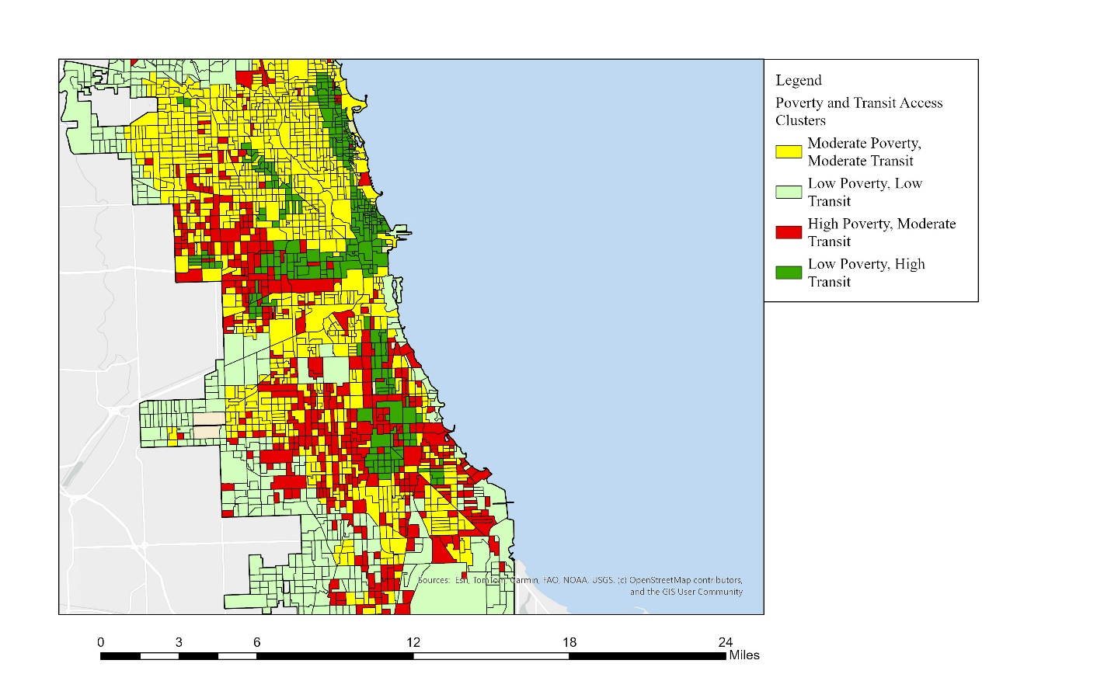

The cluster map reveals strong spatial mismatches between poverty concentration and transit availability across Chicago. Large portions of the South and West Sides fall into the High Poverty / Moderate Transit category, indicating neighborhoods where socioeconomic need is high, but transit access is only average, insufficient for populations with high transit dependence. In contrast, the Low Poverty / High Transit clusters are concentrated around the Loop, Near North Side, and lakefront neighborhoods, where residents benefit from dense, high-frequency transit networks. The map also identifies Low Poverty / Low Transit areas on the far Northwest and Southwest Sides, reflecting more suburban-like development patterns.
Overall, the clustering shows that the highest-need areas do not align with the highest levels of transit access, reinforcing structural geographic inequities in Chicago’s transportation landscape.
Table 1: Summary of Poverty Rates and Transit Density by Cluster
CLUSTER ID | FREQUENCY | POVERTY_PERCENTAGE | AVG_TRANSIT_DENSITY
1 | 1021 | 10.33 | 54.49
2 | 436 | 10.02 | 27.03
3 | 433 | 42.85 | 52.95
4 | 307 | 15.09 | 79.67

Table 1 summarizes the four spatial clusters by their frequency and mean values of poverty and transit density. Cluster 3 stands out with the highest poverty rate (42.85%) despite only moderate transit density of 52.95%, while Cluster 4 has the strongest transit access of 79.67% but relatively low poverty levels. Clusters 1 and 2 represent low-poverty groups with moderate and low transit density of 54.49 and 27.03%, respectively, reinforcing the imbalance between socioeconomic need and transit supply.
Figure 6: Dominant Commute Time by Block Group in Chicago
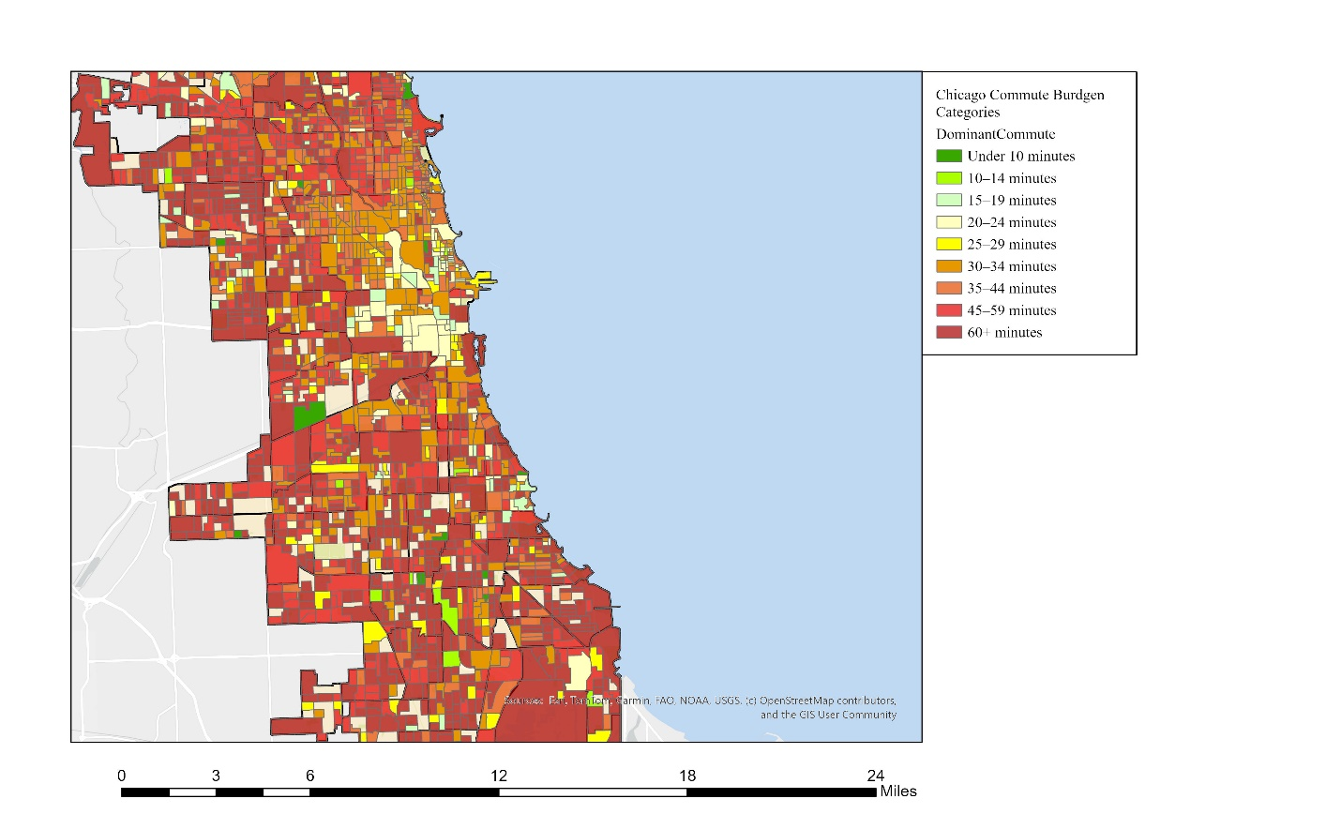
The map above symbolizes dominant commute time across each block group and the significant commute burden felt by certain neighborhoods and communities living in far-flung areas. Across many block groups on the South Side and West Side, the dominant commute category is 35–44 minutes or 45–59 minutes. Some areas, especially far South Side neighborhoods show 60+ minutes as the most common commute time. It is also observable that high-poverty neighborhoods frequently overlap with long-dominant-commute zones. These long commutes signal lower job accessibility, fewer direct routes, and reliance on slower bus-based travel. Neighborhoods farther from the Central Business District exhibit consistently longer dominant commute times, reflecting Chicago’s downtown-centric job distribution. Even some areas with moderate transit density still show long commute times, suggesting issues with transit frequency, route connectivity, and transfer times.
CONCLUSIONS:
The combined analysis of poverty concentration, transit access, and commute burden reveals a consistent and inequitable spatial pattern across Chicago. High-poverty neighborhoods on the South and West Sides experience only moderate levels of transit availability and simultaneously face the longest dominant commute times, underscoring a clear mismatch between transit dependence and transit service. In contrast, wealthier North Side and downtown-adjacent communities benefit from both dense transit networks and significantly shorter travel times, reinforcing existing socioeconomic advantages. These findings demonstrate that transit infrastructure alone is not sufficient; equitable mobility requires aligning transit investment with areas of greatest need, improving frequency and connectivity, and strengthening access to employment hubs.
REFERENCE:
- City of Chicago. (2024). CTA Bus Stops [Data set]. Chicago Data Portal. https://data.cityofchicago.org/
- City of Chicago. (2024). CTA Rail Stations [Data set]. Chicago Data Portal. https://data.cityofchicago.org/
- U.S. Census Bureau. (2022). TIGER/Line Shapefiles: Census Block Groups [Geospatial data]. https://www.census.gov/geographies/mapping-files/time-series/geo/tiger-line-file.html
- U.S. Census Bureau. (2022). American Community Survey 5-Year Estimates: Table S1701 (Poverty Status). https://data.census.gov/
- U.S. Census Bureau. (2022). American Community Survey 5-Year Estimates: Table B08303 (Travel Time to Work). https://data.census.gov/
- Selected Socioeconomic indicators by Neighborhood (data.cityofchicago.org) https://data.cityofchicago.org/Health-Human-Services/Selected-socioeconomic-indicators-by-neighborhood/i9hv-en6g/about_data
- Community Area Boundaries(shapefile, Chicago Data Portal): https://data.cityofchicago.org/Facilities-Geographic-Boundaries/Boundaries-Community-Areas-Map/cauq-8yn6

Barajas, J., & Brown, A. (2021). Not minding the gap: Does ride-hailing serve transit deserts? Journal of Transport Geography, 90.
Sanchez, T. W., Stolz, R., & Ma, J. S. (2003, June 1). Moving to equity: Addressing inequitable effects of transportation policies on minorities. The Civil Rights Project. https://civilrightsproject.ucla.edu/reports/moving-to-equity-addressing-inequitable-effects-of-transportation-policies-on-minorities/
Sanchez, T. W., Stolz, R., & Ma, J. S. (2003, June 1). Moving to equity: Addressing inequitable effects of transportation policies on minorities. The Civil Rights Project. https://civilrightsproject.ucla.edu/reports/moving-to-equity-addressing-inequitable-effects-of-transportation-policies-on-minorities/
Amaro, S. (2024, December 14). The CTA and the lack of transportation equity around the city. Red Line Project. https://redlineproject.news/2024/12/14/opinion-the-cta-and-the-lack-of-transportation-equity-around-the-city/
Barajas, J., & Brown, A. (2021). Not minding the gap: Does ride-hailing serve transit deserts? Journal of Transport Geography, 90.
Amaro, S. (2024, December 14). The CTA and the lack of transportation equity around the city. Red Line Project. https://redlineproject.news/2024/12/14/opinion-the-cta-and-the-lack-of-transportation-equity-around-the-city/

